mihi nomen est:

Which pieces of modern furniture belong in which room? Responde Latine!

| triclinium  culina  hortus  tablinum  cubiculum | latrina  taberna  impluvium  atrium  ianua / fauces |
| --- | --- |

1. 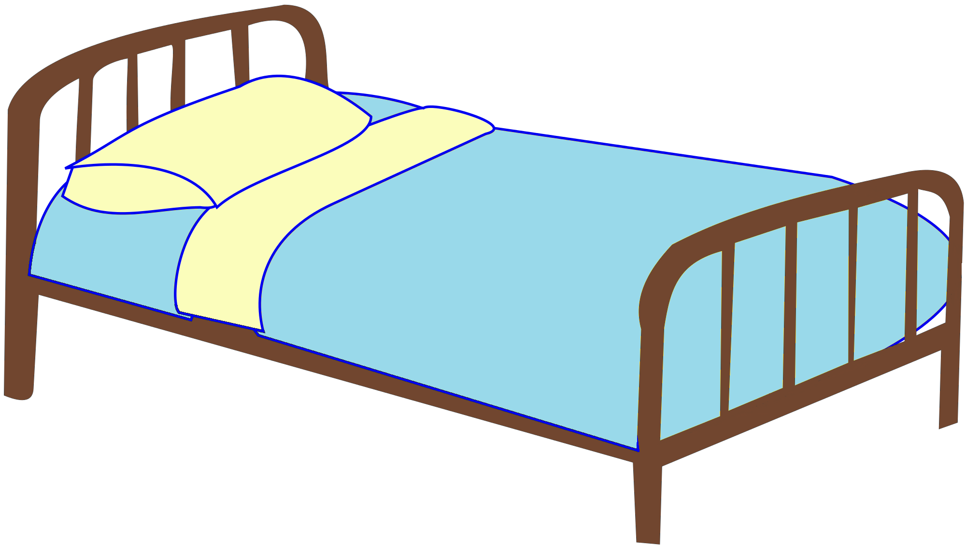 _____________________________
2.  _____________________________
3.  ______________________________
4. 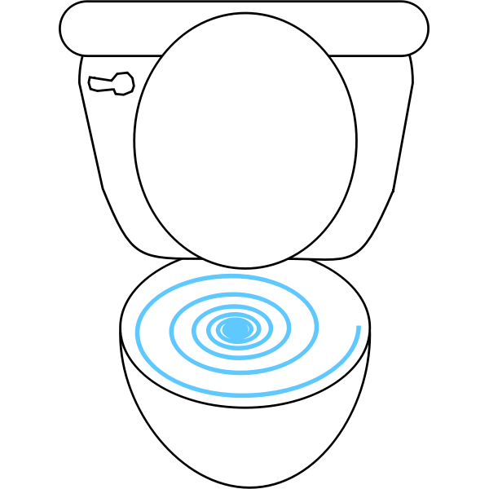 ______________________________
5. 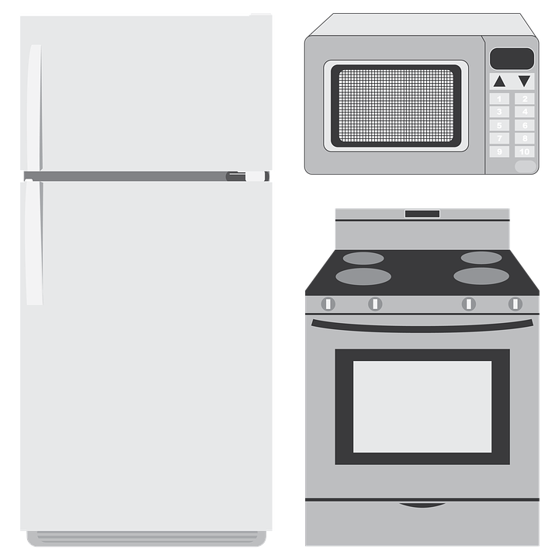 _______________________________
6. 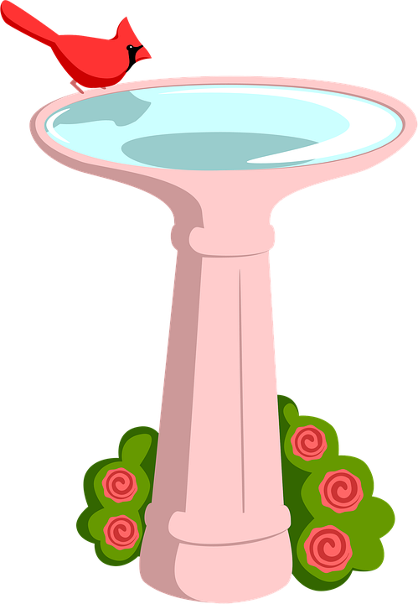 _______________________________
7.  